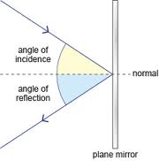
Name:_____________________

Reflection Quiz

Label the diagram above using the following words:

- Angle of incidence
- Angle of reflection
- Incident ray
- Reflected ray
- Normal
- Plane mirror

What is the law of reflection?

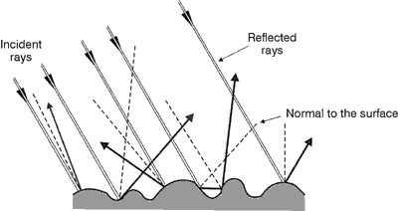
What sort of reflection is shown in this diagram?

Will this sort of reflection form an image?

Why or Why not?

